Teach 21 Project
Wiki Response to Featured Writing
6th Grade ELA
(Walker’s Wiki Writes & Wiki Reads)

All students will write on an assigned topic once a week during ELT, free-write on any topic once a week in class and creatively write periodically throughout the year. At the end of the month, four featured writings will be posted to the wiki. Students will be responsible for posting a response to their choice of writing. In their responses, students will evaluate the writing in the areas of Ideas, Sentence Fluency, Word Choice, Conventions, Organization, Voice, Creativity, and the Writer’s ability to capture the reader. The writing to receive the most wiki responses will be featured on the Teacher’s Classroom page via audio podcast. At the end of the grading term, students will write a wiki reflection to be placed in their writing portfolio. Additionally, at the end of the year, the students will also write final wiki reflection on all of the featured writings. A short video of their opinions of the project will be prepared for upcoming students.

Tools Needed:
- Computers on Wheels (COWS)
- Six Headsets with Microphones
- Flip Camera for Video Podcasting of Featured Writing
- Wiki Access/Storage
- Web Page/Classroom Page Storage
- Available Tech Support

Standards:

Georgia Performance Standards
ELA6W1
The students will produce writing that establishes an appropriate organizational structure, sets a context and engages the reader, maintains a coherent focus throughout, and provides a satisfying closure.

ELA6W2
The student will demonstrate competence in a variety of genres.

ELA6C1
The students will demonstrate understanding and control of the rules of the English language, realizing that usage involves the appropriate application of conventions and grammar in both written and spoken formats.

ELA6LV1
The students will participate in student-to-teacher, student-to-student, and group verbal interactions.

ELA6LV2
The students will listen to and view various forms of text and media in order to share information, persuade others, and express and understand ideas. The student will select and critically analyze messages using rubrics as assessment tools.

ELA6W4
The students will consistently use the writing process to develop, revise, and evaluate writing.

National Educational Technology Standards

Creativity and Innovation
Students demonstrate creative thinking, construct knowledge, and develop innovative products and processes using technology.

Technology Operations and Concepts
Students demonstrate a sound understanding of technology concepts, systems, and operations.
Communication and Collaboration
Students use digital media and environments to communicate and work collaboratively, including at a distance, to support individual learning and contribute to the learning of others.

Digital Citizenship
Students understand human, cultural, and societal issues related to technology and practice legal and ethical behavior.

Medium/Higher Order Thinking Skills

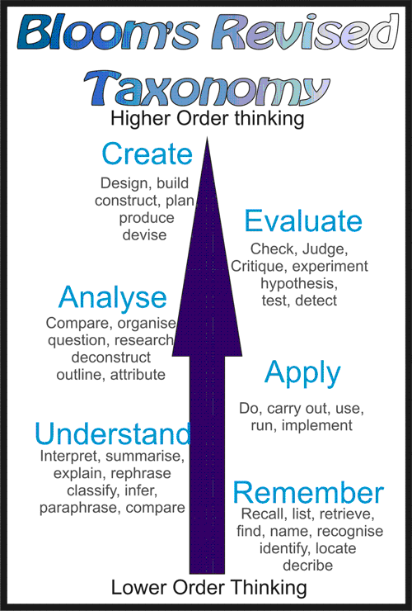
Apply
Analyse
Evaluate
Create

